TEAM ID : PNT2022TMID12783

PROJECT TITLE : Industry-Specific Intelligent Fire Management System

PROGRAM

#include "DHTesp.h"

#include <cstdlib> #include <time.h>

const int DHT_PIN = 15;

bool is_exhaust_fan_on = false; bool is_sprinkler_on = false;

float temperature = 0;

int gas_ppm = 0;

int fire = 0; int flow = 0;

String fire_status = "";

String accident_status = "";

String sprinkler_status = ""; DHTesp dhtSensor;

void setup() {

Serial.begin(99900);

dhtSensor.setup(DHT_PIN, DHTesp::DHT22);

}

void loop() {

TempAndHumidity data = dhtSensor.getTempAndHumidity();

srand(time(0));

temperature = data.temperature; gas_ppm = rand()%1000; int firereading = rand()%1024; fire = map(firereading,0,1024,0,1024); int firerange = map(firereading,0,1024,0,3); int flow = ((rand()%100)>50?1:0);

switch (firerange) { case 2: fire_status = "Close Fire"; break; case 1: fire_status = "Distant Fire"; break; case 0: fire_status = "No Fire"; break;

}

if(gas_ppm > 100){ is_exhaust_fan_on = true;

}

else{ is_exhaust_fan_on = false;

}

if(temperature < 40 && firerange ==2){ accident_status = "need auditing"; is_sprinkler_on = false;

}

else if(temperature < 40 && firerange ==0){ accident_status = "nothing found"; is_sprinkler_on = false;

}

else if(temperature > 50 && firerange == 1){ is_sprinkler_on = true; accident_status = "moderate";

}

else if(temperature > 55 && firerange == 2){ is_sprinkler_on = true; accident_status = "severe";

}else{ is_sprinkler_on = false; accident_status = "nil"; }

if(is_sprinkler_on){ if(flow){

sprinkler_status = "working";

}

else{

sprinkler_status = "not working";

}

}

else if(is_sprinkler_on == false){ sprinkler_status = "now it shouldn't";

}

else{

sprinkler_status = "something's wrong";

}

String out = "{\n\t\"senor_values\":{"; out+="\n\t\t\"gas_ppm\":"+String(gas_ppm)+","; out+="\n\t\t\"temperature\":"+String(temperature,2)+","; out+="\n\t\t\"fire\":"+String(fire)+","; out+="\n\t\t\"flow\":"+String(flow)+",\n\t}"; out+="\n\t\"output\":{"; out+="\n\t\ t\"is_exhaust_fan_on\":"+String((is_exhaust_fan_on)?"true":"false")+","; out+="\n\t\t\"is_sprinkler_on\":"+String((is_sprinkler_on)?"true":"false")+","; out+="\n\t}";

out+="\n\t\"messages\":{"; out+="\n\t\t\"fire_status\":"+fire_status+","; out+="\n\t\t\"flow_status\":"+sprinkler_status+","; out+="\n\t\t\"accident_status\":"+accident_status+","; out+="\n\t}"; out+="\n}"; Serial.println(out);

delay(1000);

}

DIAGRAM.JSON:

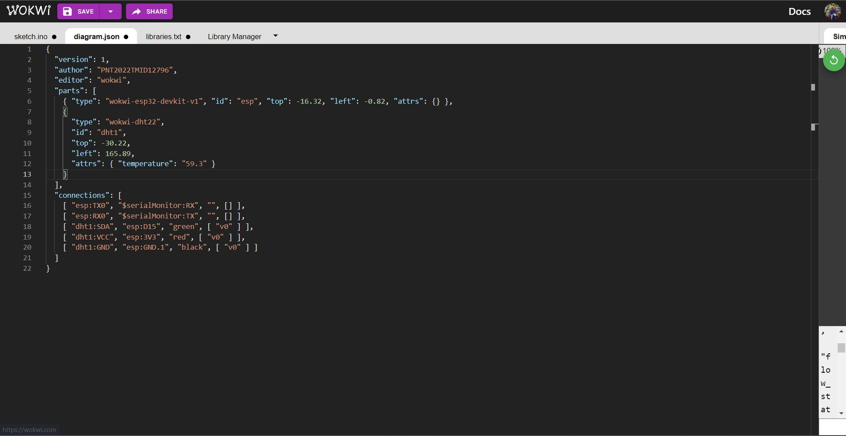

LIBRARIES TEXT:

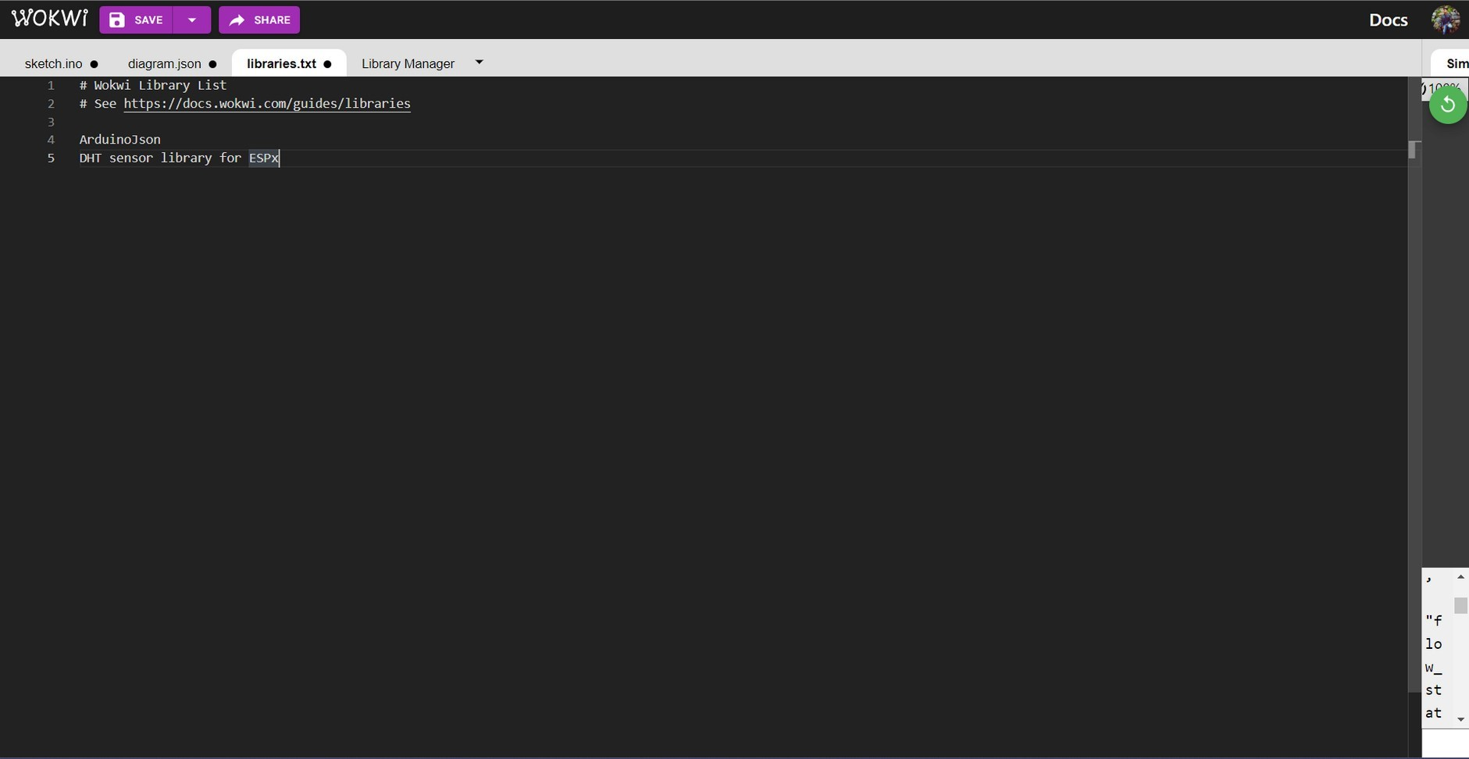

CIRCUIT:

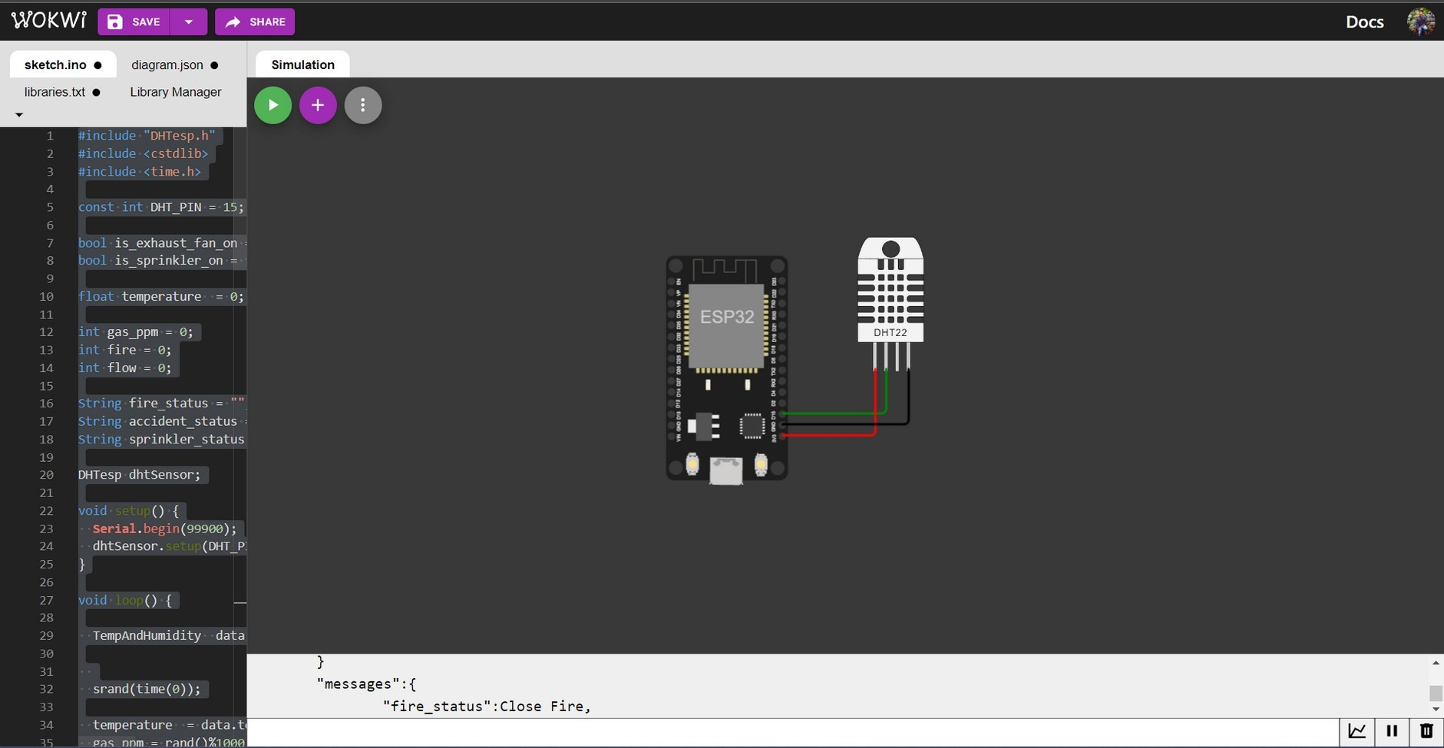

OUTPUT:

